Name: Siddhesh Jadhav

Roll no: 08

Batch: A1

**Chain Code**

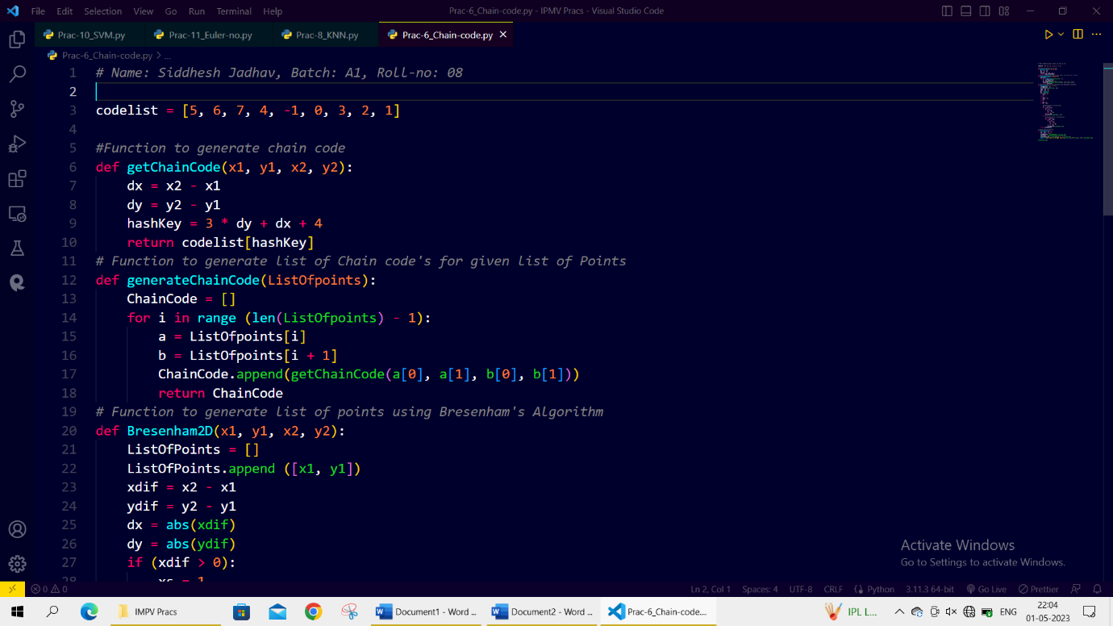**Code:**

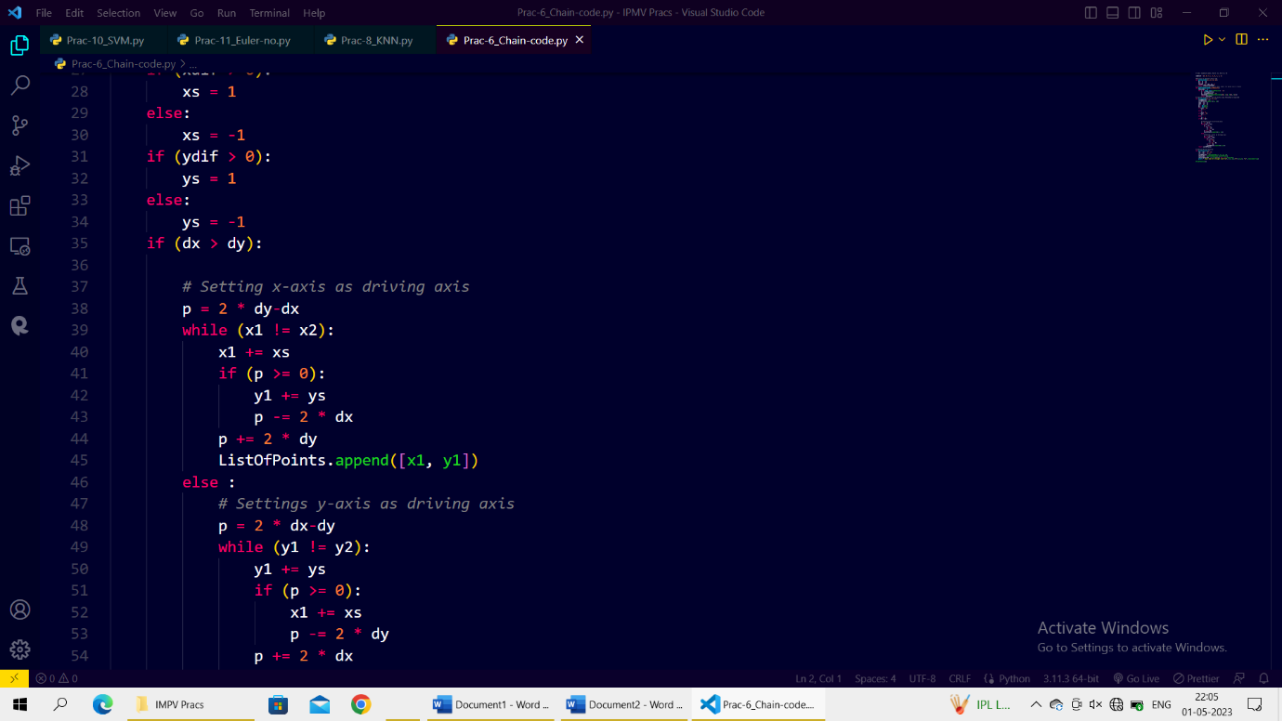

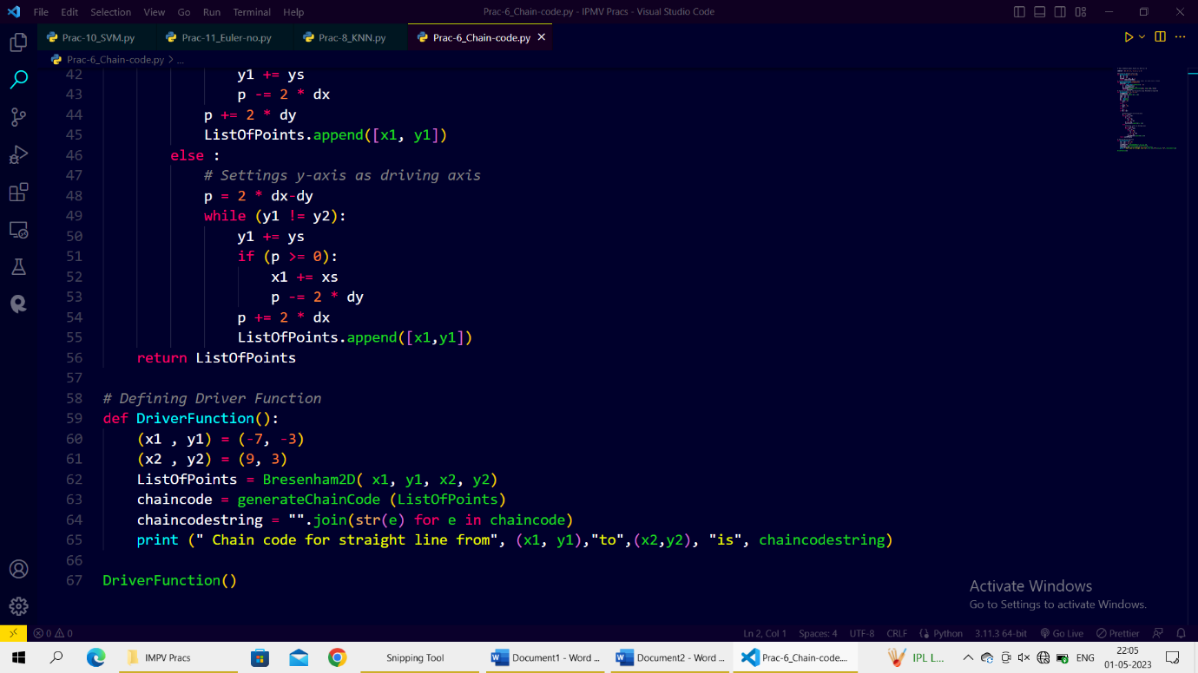**Output**:

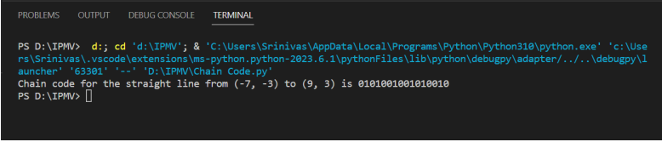

Name: Siddhesh Jadhav

Roll no: 08

Batch: A1

**Canny Edge Detection**

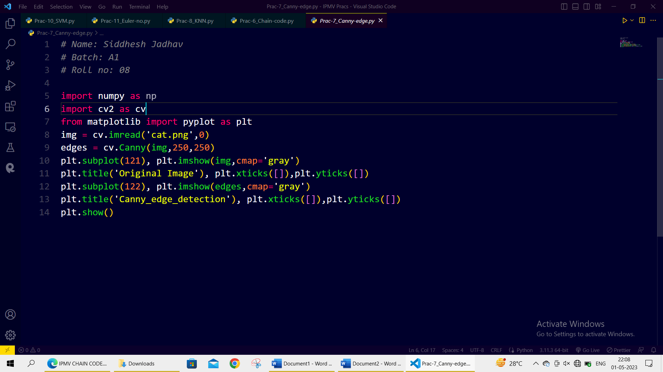

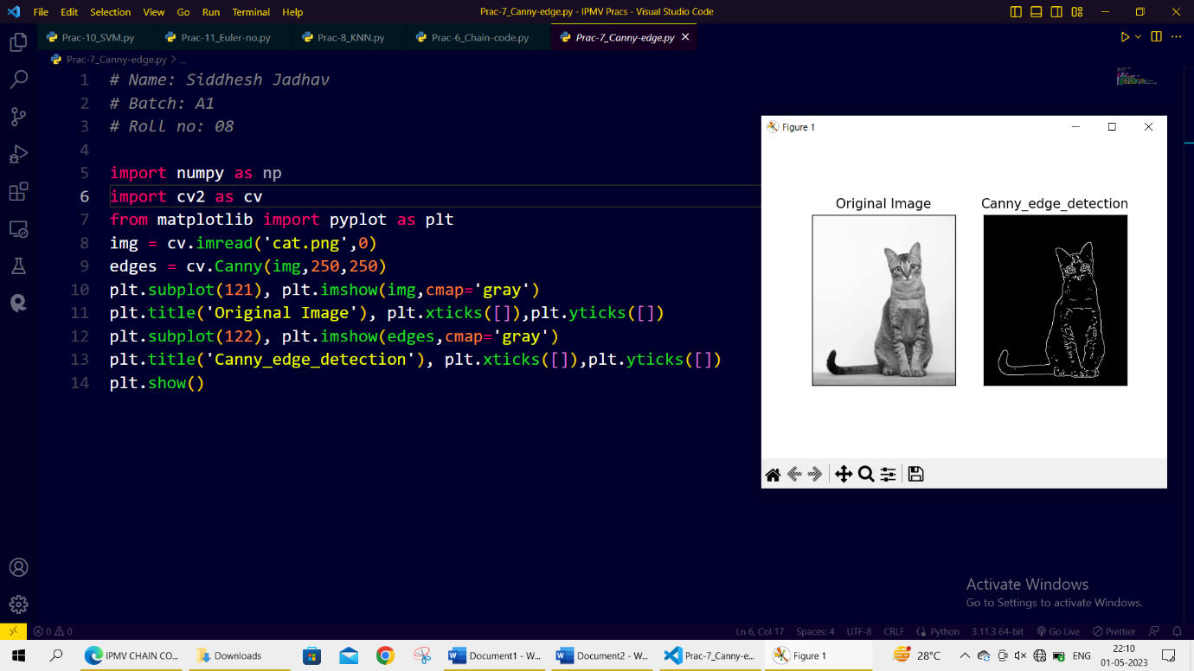

Name: Siddhesh Jadhav

Roll no: 08

Batch: A1

**KNN**

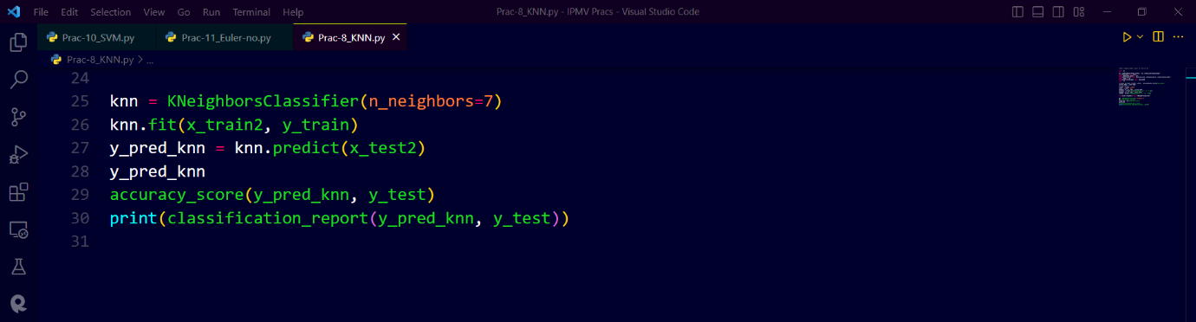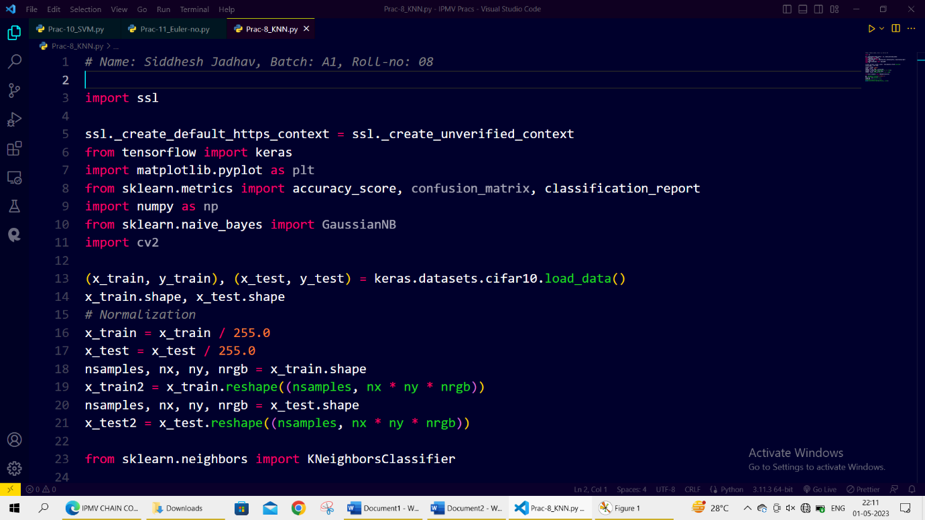**Code:**

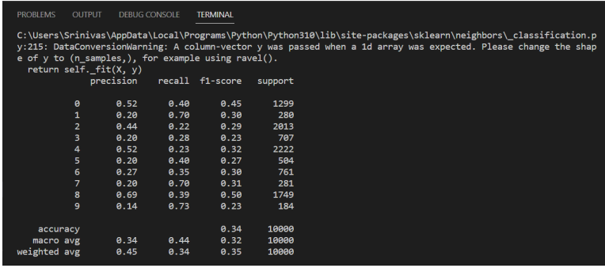**Output:**

Name: Siddhesh Jadhav

Roll no: 08

Batch: A1

**Bassiyan Classifier**

**Code:**

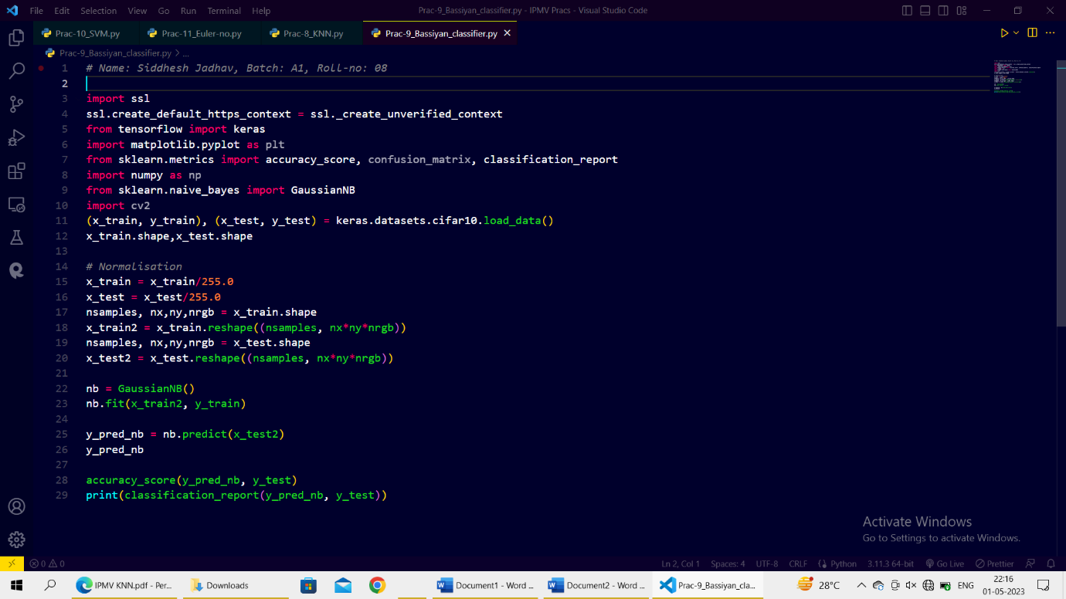

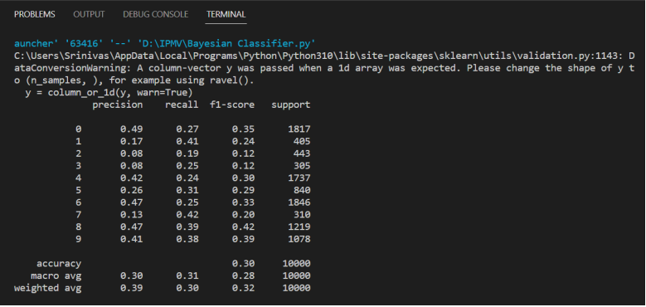**Output:**

Name: Siddhesh Jadhav

Roll no: 08

Batch: A1

**Support Vector Machine (SVM)**

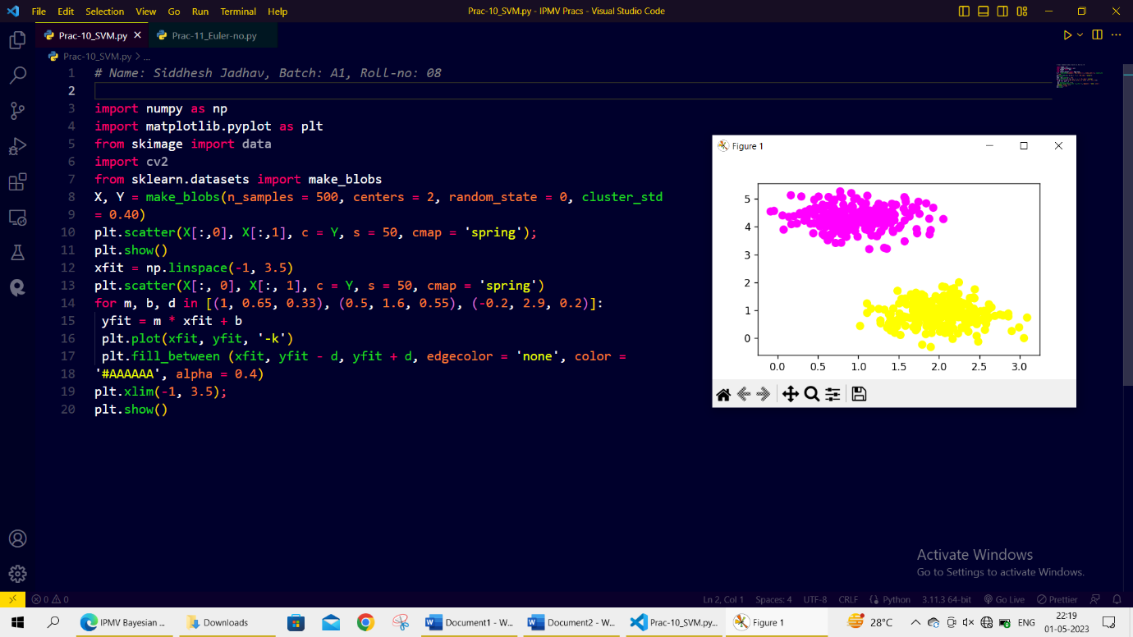

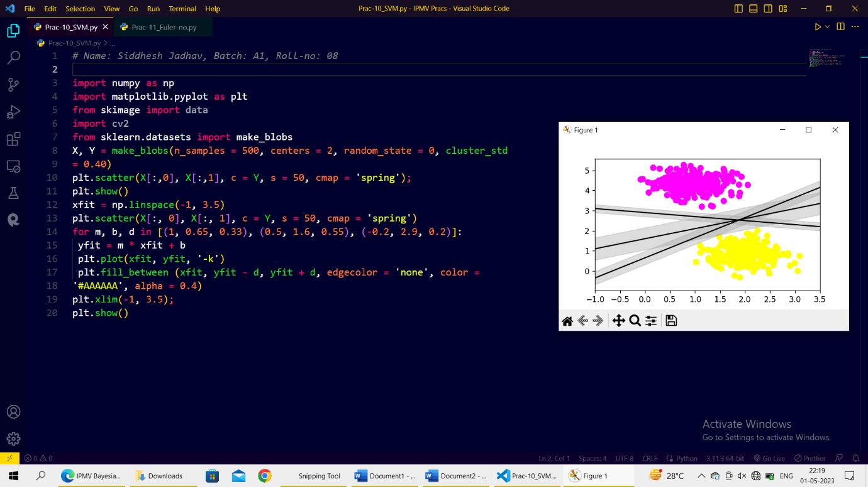

Name: Siddhesh Jadhav

Roll no: 08

Batch: A1

**Euler Number**

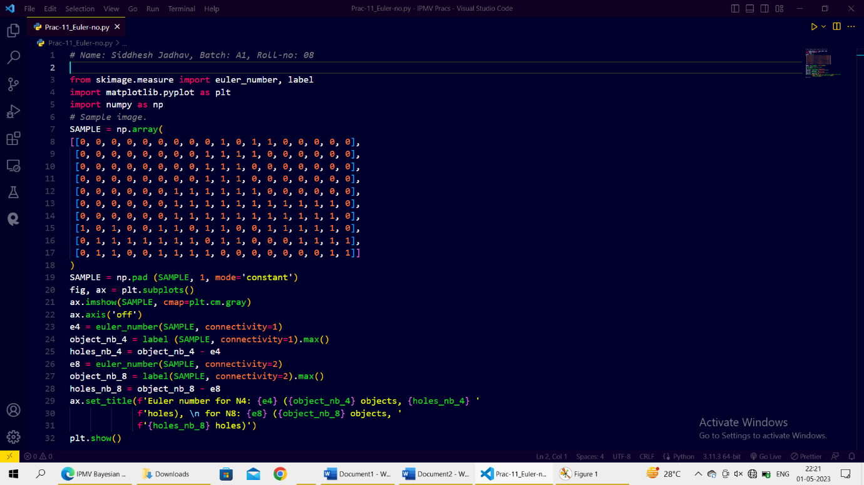**Code:**

